function updateInvoice(processedInvoiceItemsJSON, updateDerivedFields) {

var i, updatedInvoiceItems = [];

try{

for( i = 0; i < processedInvoiceItemsJSON.length; i++ ){

updatedInvoiceItems.push(updateInvoiceItemEntry(processedInvoiceItemsJSON[i], updateDerivedFields));

}

// Set the invoice status as 'In_Progress', everytime it is edited or

// saved. The step to update the status should be performed only once,

// the first time this function is invoked

// if(!updateDerivedFields){

// updateInvoiceStatus(processedInvoiceItemsJSON[0].invoiceGUID, invoiceStatus.inProgress, "", "");

// }

} catch(exception){

throw exception;

}

return updatedInvoiceItems;

}

function clearExceptions(invoiceGUID){

// Delete the exception entries corresponding to the invoice GUID

invoiceExceptions.$delete({ invoiceGUID: invoiceGUID });

}

function updatePostedInvoice(invoiceGUID, postedInvoice){

try{

// Read the invoice items corresponding to the invoice GUID

var invoiceItems = readInvoice(invoiceGUID);

var i, invoiceItem, invoiceItemEntry;

// Read the invoice entries and update the status and the posted invoice

// # in each of them

for(i = 0; i < invoiceItems.length; i++){

invoiceItem = invoiceItems[i];

invoiceItemEntry = processedInvoices.$get({

invoiceGUID: invoiceItem.invoiceGUID,

invoiceID: invoiceItem.invoiceID,

invoiceItemIndex: invoiceItem.invoiceItemIndex

});

invoiceItemEntry.invoiceStatus = "Posted";

invoiceItemEntry.postedInvoice = postedInvoice;

invoiceItemEntry.$save();

}

} catch(exception){

throw exception;

}

}

function updateExceptionWorkflowEntry(

invoiceGUID,

ginvoiceExceptionsJSON,

invoiceWorkflowExceptionItems

) {

let i = 0,

j = 0;

let exceptionStatus = null;

var exceptionWorkflowItems = [];

var invoiceExceptionsJSON = ginvoiceExceptionsJSON?ginvoiceExceptionsJSON:[];

for (i = 0; i < invoiceWorkflowExceptionItems.length; i++) {

exceptionStatus = {};

var valueOfExceptionStatus = "SUCCESS";

for (j = 0; j < invoiceExceptionsJSON.length; j++) {

if (

invoiceExceptionsJSON[j].exceptionMessage.indexOf(

invoiceWorkflowExceptionItems[i].invoiceWorkflowExceptionId

) === 0

) {

if (invoiceWorkflowExceptionItems[i].bypassStatus.toLowerCase() === "true") {

valueOfExceptionStatus = "WARNING";

} else {

valueOfExceptionStatus = "ERROR";

}

}

}

exceptionStatus.exceptionStatus = valueOfExceptionStatus;

exceptionStatus.invoiceWorkflowExceptionId = invoiceWorkflowExceptionItems[i].invoiceWorkflowExceptionId;

exceptionStatus.invoiceGUID = invoiceGUID;

exceptionStatus.messageText = "";

exceptionStatus.exceptionRule=invoiceWorkflowExceptionItems[i].exceptionRule;

exceptionStatus.assignTo=invoiceWorkflowExceptionItems[i].assignTo;

exceptionWorkflowItems.push(exceptionStatus);

}

return exceptionWorkflowItems;

}

function updateInvoiceDisplayWorkflow(invoiceGUID, exceptionWorkflowItems) {

let invoiceDisplayWorkflowItems = InvoiceDisplayWorkflows.$findAll({

invoiceGUID: invoiceGUID

},100);

if (

invoiceDisplayWorkflowItems &&

invoiceDisplayWorkflowItems.length === 0

) {

for (let i = 0; i < exceptionWorkflowItems.length; i++) {

const newinvoiceDisplayWorkflowItems = new InvoiceDisplayWorkflows({

invoiceGUID: invoiceGUID,

invoiceWorkflowExceptionId:

exceptionWorkflowItems[i].invoiceWorkflowExceptionId,

exceptionStatus: exceptionWorkflowItems[i].exceptionStatus,

invoiceDisplayWorkflowId:invoiceGUID + "_" + exceptionWorkflowItems[i].invoiceWorkflowExceptionId

});

newinvoiceDisplayWorkflowItems.$save();

exceptionWorkflowItems[i].userbypassStatus="false";

}

} else {

invoiceDisplayWorkflowItems.sort(function(a, b){

return a.invoiceWorkflowExceptionId.localeCompare(b.invoiceWorkflowExceptionId);

}

);

exceptionWorkflowItems.sort(function (a, b) {

return a.invoiceWorkflowExceptionId.localeCompare(b.invoiceWorkflowExceptionId);

}

);

for(let i = 0;i < invoiceDisplayWorkflowItems.length;i++){

if(invoiceDisplayWorkflowItems[i].userbypassStatus.toLowerCase()==="true"){

invoiceDisplayWorkflowItems[i].exceptionStatus="SUCCESS";

exceptionWorkflowItems[i].exceptionStatus="SUCCESS";

}else{

invoiceDisplayWorkflowItems[i].exceptionStatus = exceptionWorkflowItems[i].exceptionStatus;

exceptionWorkflowItems[i].messageText=invoiceDisplayWorkflowItems[i].messageText;

}

//exceptionWorkflowItems[i].userbypassStatus=invoiceDisplayWorkflowItems[i].userbypassStatus;

invoiceDisplayWorkflowItems[i].$save();

}

}

}

function updateInvoiceDisplayWorkflowItems(exceptionWorkflowItems){

if(exceptionWorkflowItems && exceptionWorkflowItems.length){

for(let i=0;i<exceptionWorkflowItems.length;i++){

let invoiceDisplayWorkflowItem = InvoiceDisplayWorkflows.$findAll({

invoiceGUID: exceptionWorkflowItems[i].invoiceGUID,

invoiceWorkflowExceptionId:exceptionWorkflowItems[i].invoiceWorkflowExceptionId

},

1);

if(invoiceDisplayWorkflowItem[0].messageText!==exceptionWorkflowItems[i].messageText

&& exceptionWorkflowItems[i].messageText){

invoiceDisplayWorkflowItem[0].messageText=exceptionWorkflowItems[i].messageText;

}

if(invoiceDisplayWorkflowItem[0].userbypassStatus!==exceptionWorkflowItems[i].userbypassStatus

&& exceptionWorkflowItems[i].userbypassStatus){

invoiceDisplayWorkflowItem[0].userbypassStatus=exceptionWorkflowItems[i].userbypassStatus;

}

invoiceDisplayWorkflowItem[0].$save();

}

}

}

function updateDisplayExceptions(invoiceGUID,invoiceExceptionsJSON){

var invoiceWorkflowExceptionItems = workflowExceptions.$findAll({},100);

var exceptionWorkflowItems = updateExceptionWorkflowEntry(invoiceGUID,invoiceExceptionsJSON,invoiceWorkflowExceptionItems);

updateInvoiceDisplayWorkflow(invoiceGUID, exceptionWorkflowItems);

return exceptionWorkflowItems;

}

function updateExceptions(invoiceExceptionsJSON){

var i, invoiceException, newInvoiceExceptions = [], newInvoiceException;

try{

// Insert the newly generated exceptions corresponding to the invoice

for( i = 0; i < invoiceExceptionsJSON.length; i++){

invoiceException = invoiceExceptionsJSON[i];

newInvoiceException = new invoiceExceptions({

"invoiceGUID": invoiceException.invoiceGUID,

"exceptionIndex": invoiceException.exceptionIndex,

"exceptionMessage": invoiceException.exceptionMessage

});

newInvoiceException.$save();

newInvoiceExceptions.push(newInvoiceException);

}

} catch(exception){

throw exception;

}

return newInvoiceExceptions;

}

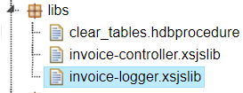

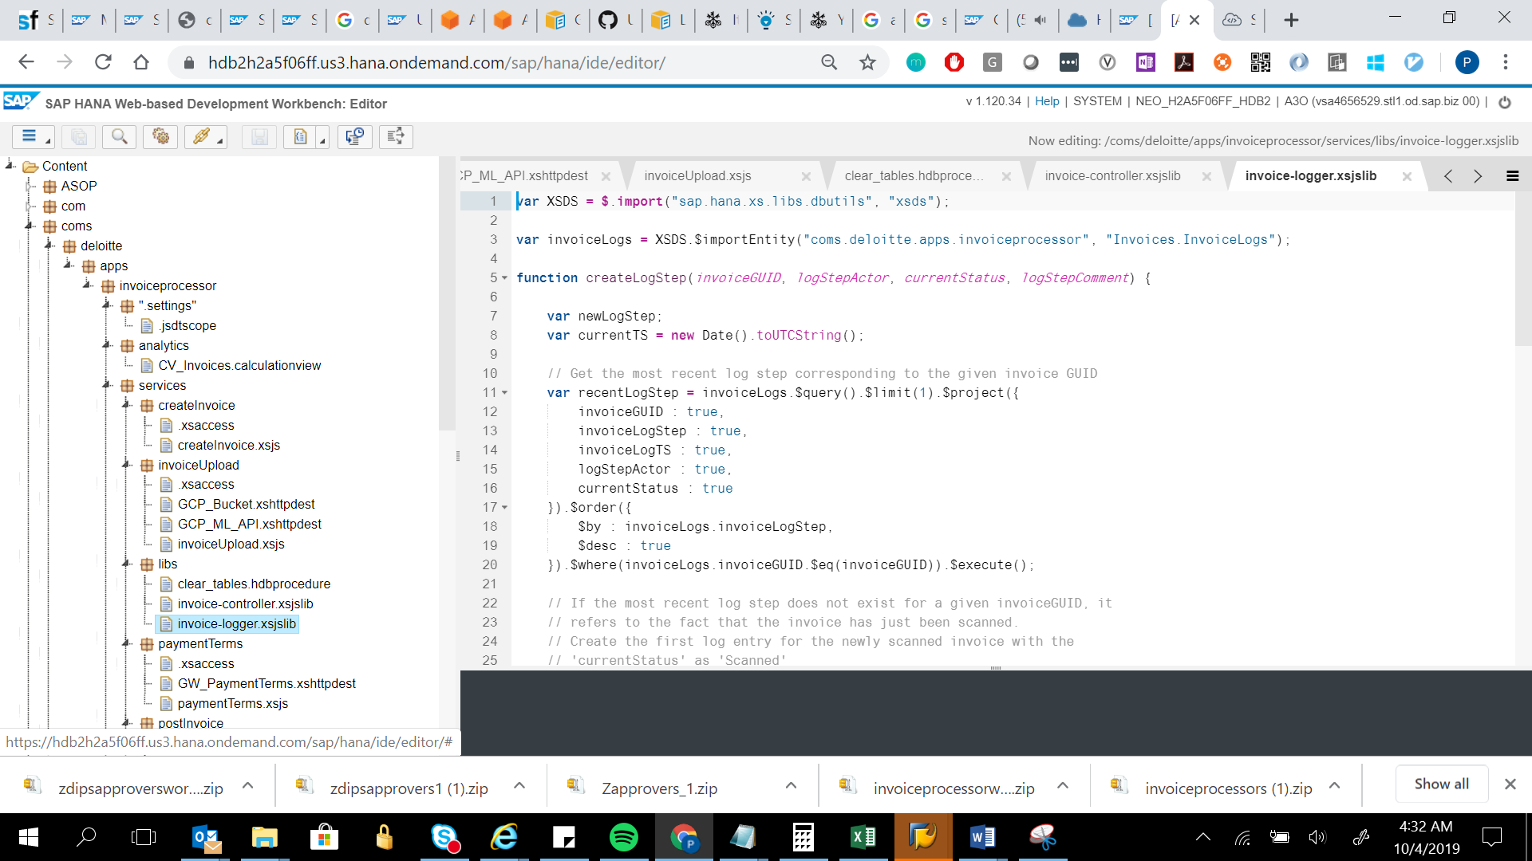

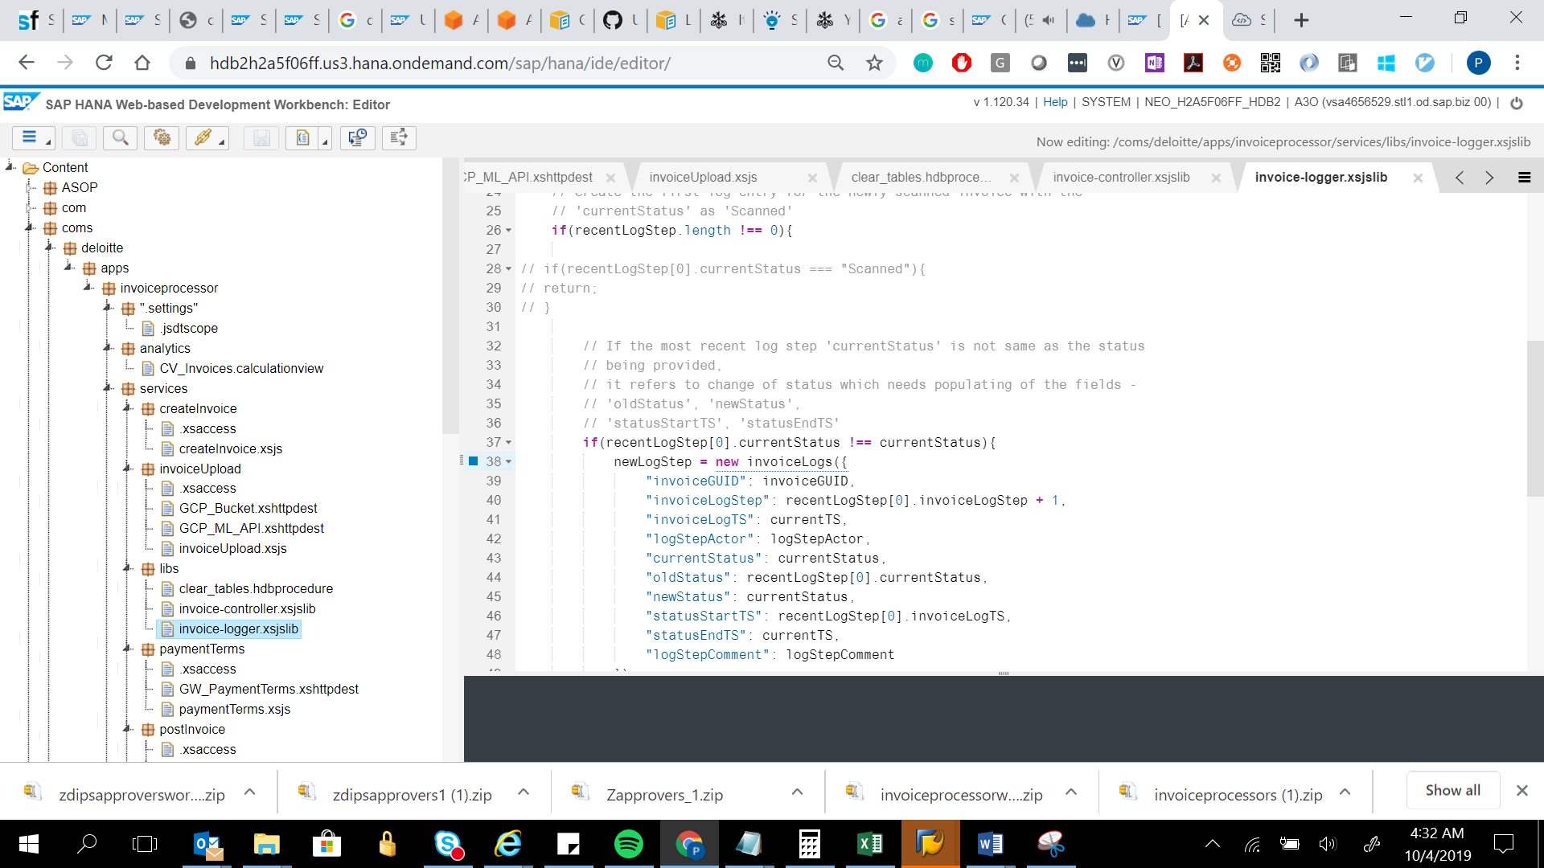

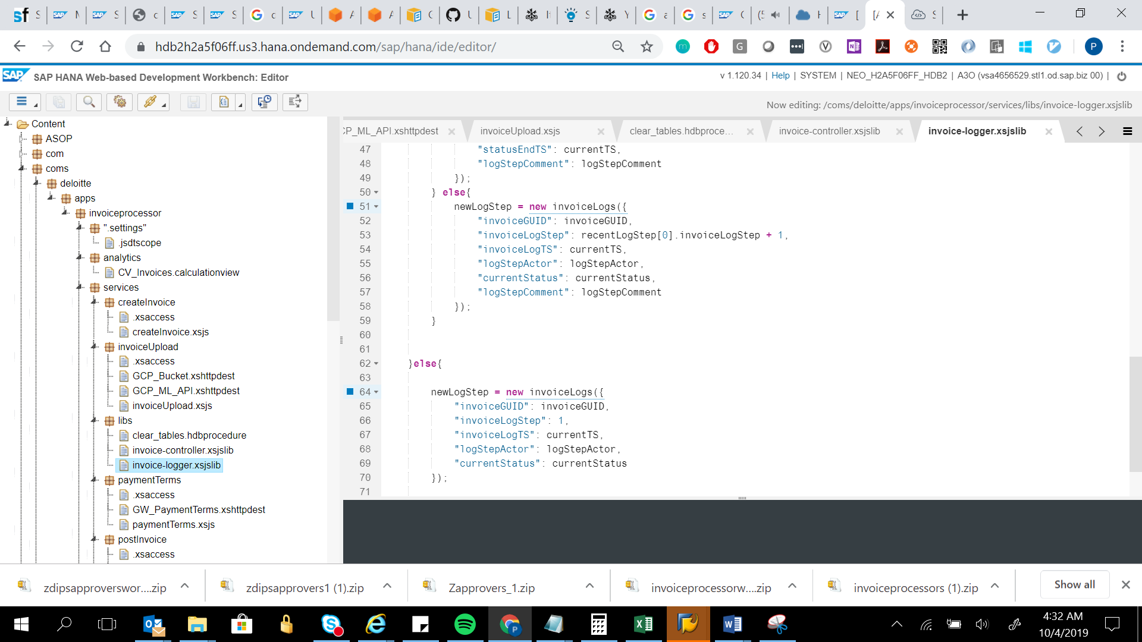

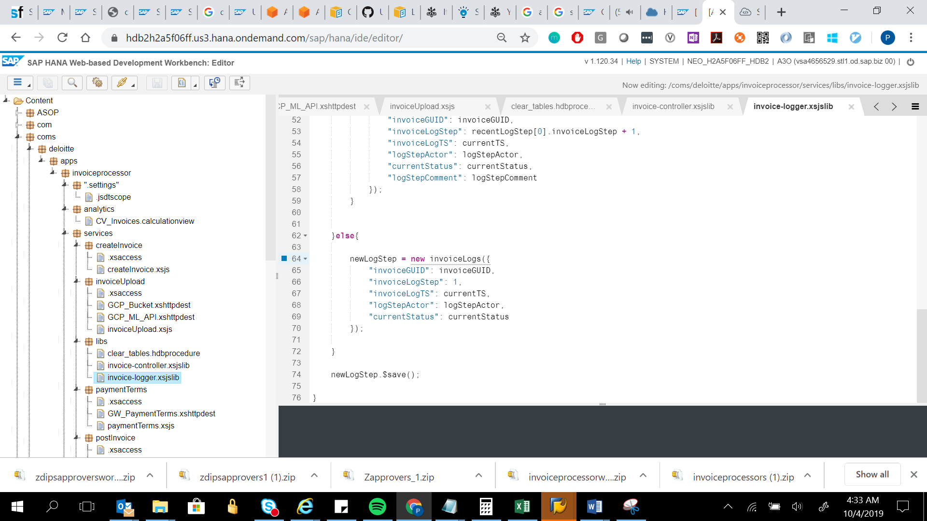

var XSDS = $.import("sap.hana.xs.libs.dbutils", "xsds");

var invoiceLogs = XSDS.$importEntity("coms.deloitte.apps.invoiceprocessor", "Invoices.InvoiceLogs");

function createLogStep(invoiceGUID, logStepActor, currentStatus, logStepComment) {

var newLogStep;

var currentTS = new Date().toUTCString();

// Get the most recent log step corresponding to the given invoice GUID

var recentLogStep = invoiceLogs.$query().$limit(1).$project({

invoiceGUID : true,

invoiceLogStep : true,

invoiceLogTS : true,

logStepActor : true,

currentStatus : true

}).$order({

$by : invoiceLogs.invoiceLogStep,

$desc : true

}).$where(invoiceLogs.invoiceGUID.$eq(invoiceGUID)).$execute();

// If the most recent log step does not exist for a given invoiceGUID, it

// refers to the fact that the invoice has just been scanned.

// Create the first log entry for the newly scanned invoice with the

// 'currentStatus' as 'Scanned'

if(recentLogStep.length !== 0){

// if(recentLogStep[0].currentStatus === "Scanned"){

// return;

// }

// If the most recent log step 'currentStatus' is not same as the status

// being provided,

// it refers to change of status which needs populating of the fields -

// 'oldStatus', 'newStatus',

// 'statusStartTS', 'statusEndTS'

if(recentLogStep[0].currentStatus !== currentStatus){

newLogStep = new invoiceLogs({

"invoiceGUID": invoiceGUID,

"invoiceLogStep": recentLogStep[0].invoiceLogStep + 1,

"invoiceLogTS": currentTS,

"logStepActor": logStepActor,

"currentStatus": currentStatus,

"oldStatus": recentLogStep[0].currentStatus,

"newStatus": currentStatus,

"statusStartTS": recentLogStep[0].invoiceLogTS,

"statusEndTS": currentTS,

"logStepComment": logStepComment

});

} else{

newLogStep = new invoiceLogs({

"invoiceGUID": invoiceGUID,

"invoiceLogStep": recentLogStep[0].invoiceLogStep + 1,

"invoiceLogTS": currentTS,

"logStepActor": logStepActor,

"currentStatus": currentStatus,

"logStepComment": logStepComment

});

}

}else{

newLogStep = new invoiceLogs({

"invoiceGUID": invoiceGUID,

"invoiceLogStep": 1,

"invoiceLogTS": currentTS,

"logStepActor": logStepActor,

"currentStatus": currentStatus

});

}

newLogStep.$save();

}

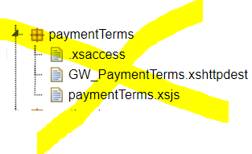

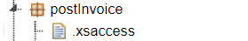

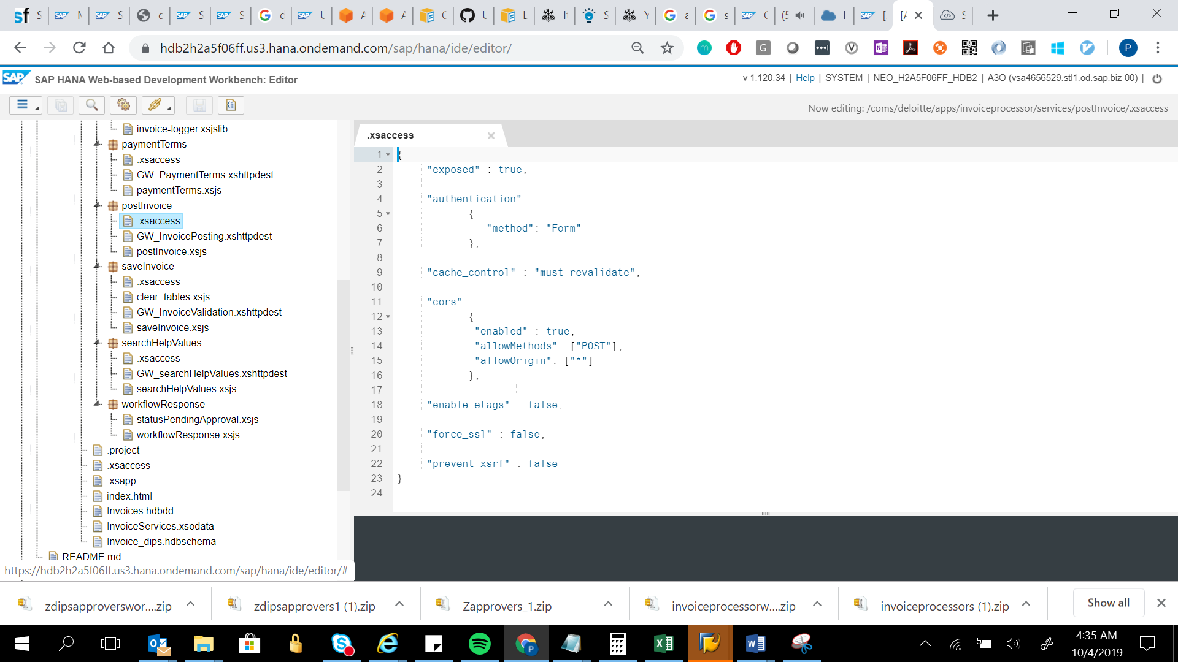

{

"exposed" : true,

"authentication" :

{

"method": "Form"

},

"cache_control" : "must-revalidate",

"cors" :

{

"enabled" : true,

"allowMethods": ["POST"],

"allowOrigin": ["*"]

},

"enable_etags" : false,

"force_ssl" : false,

"prevent_xsrf" : false

}

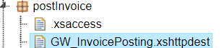

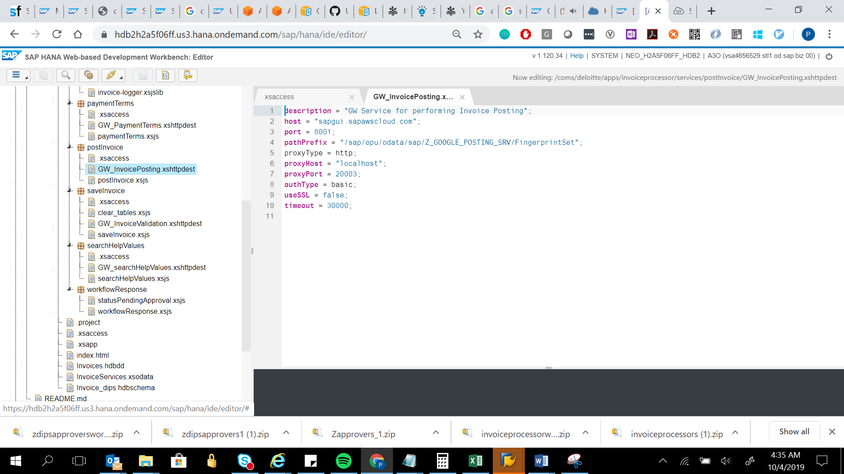

description = "GW Service for performing Invoice Posting";

host = "sapgui.sapawscloud.com";

port = 8001;

pathPrefix = "/sap/opu/odata/sap/Z_GOOGLE_POSTING_SRV/FingerprintSet";

proxyType = http;

proxyHost = "localhost";

proxyPort = 20003;

authType = basic;

useSSL = false;

timeout = 30000;

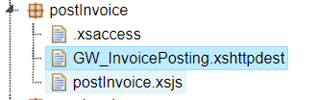

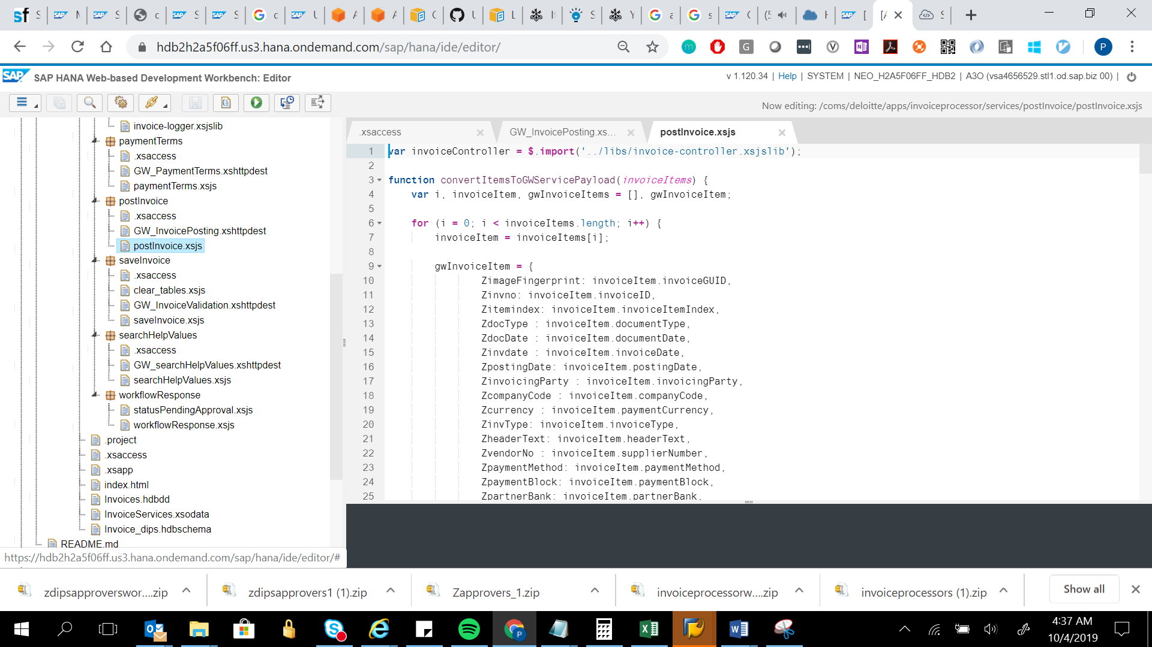

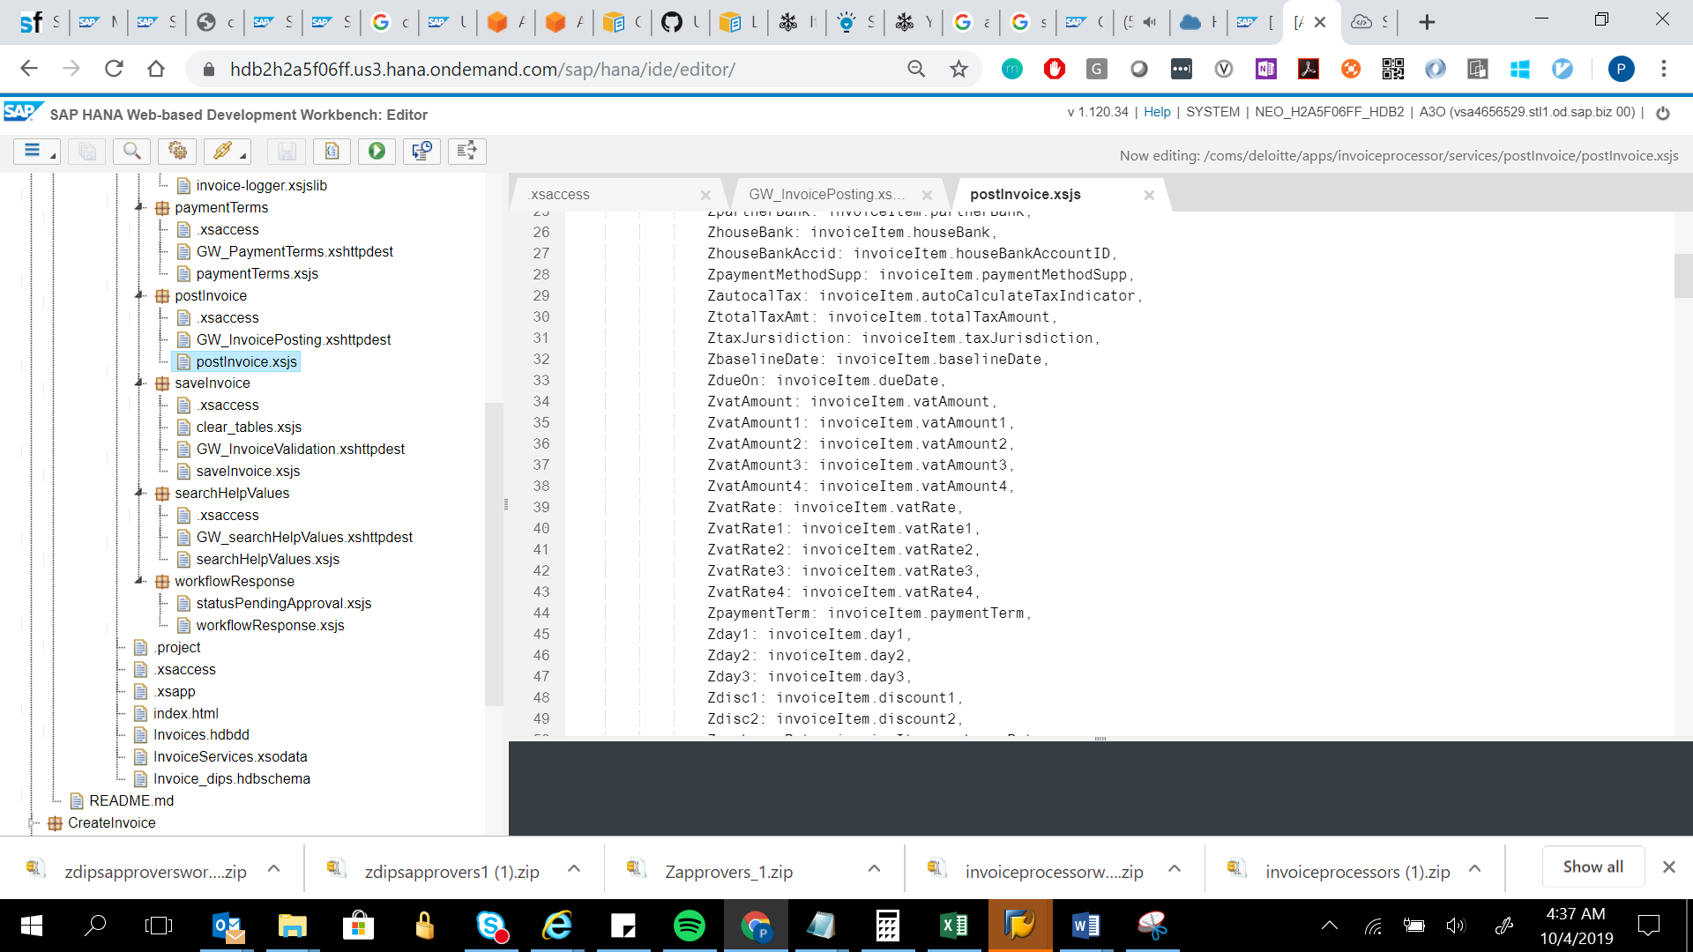

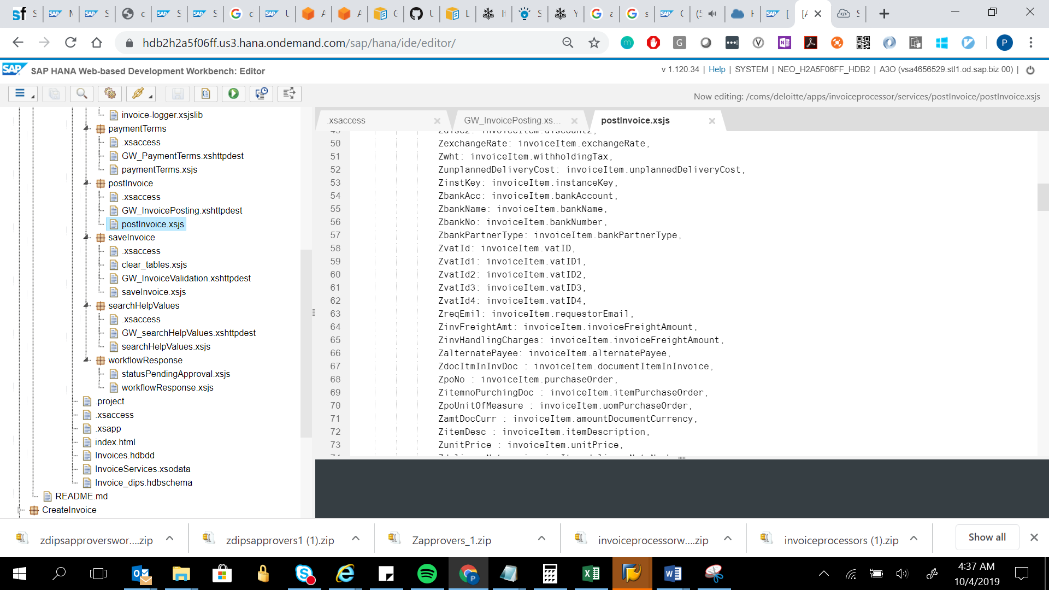

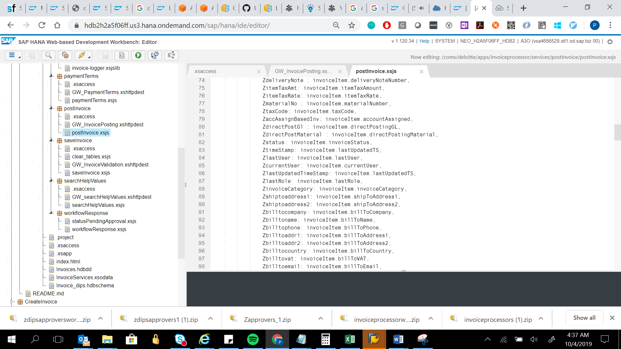

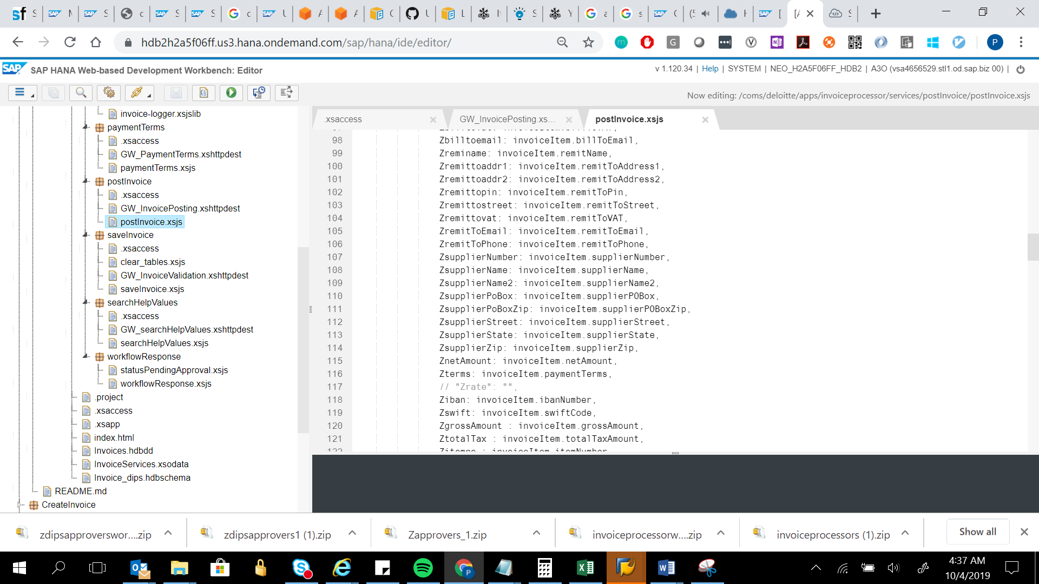

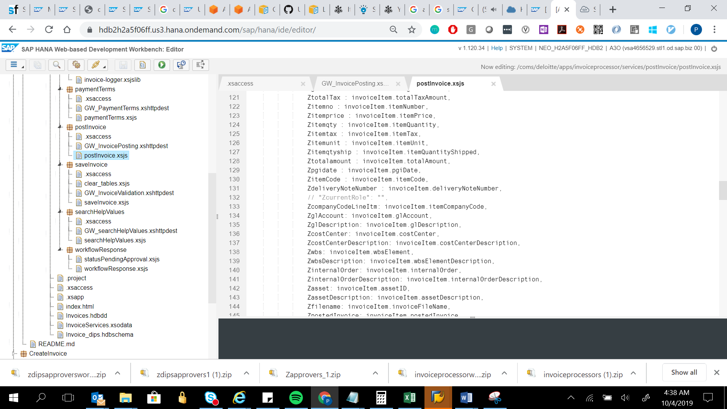

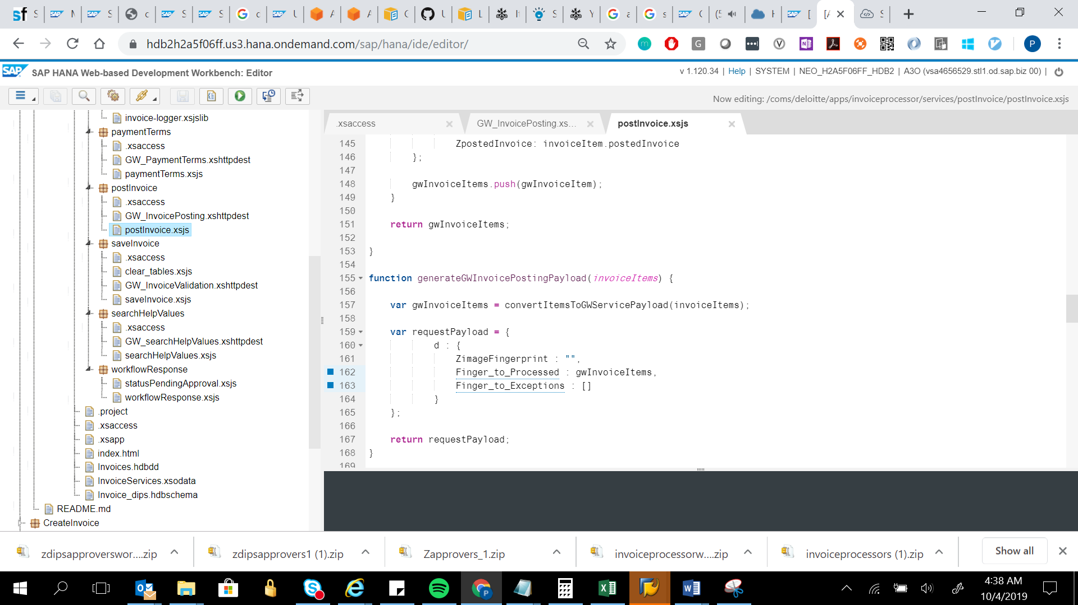

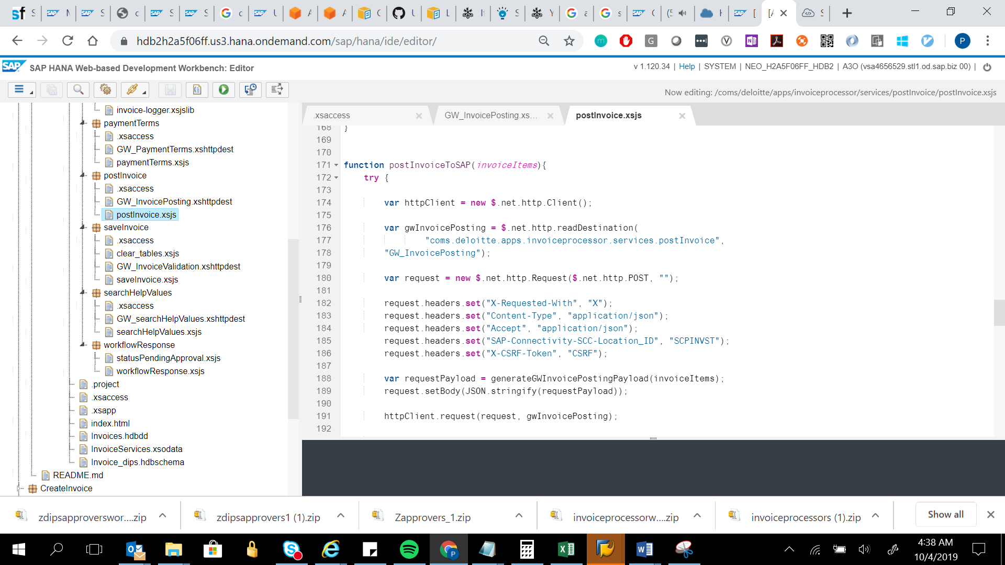

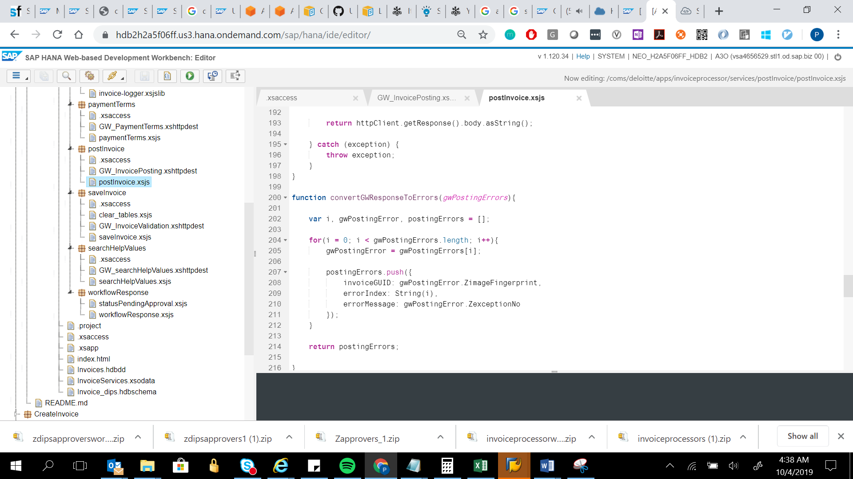

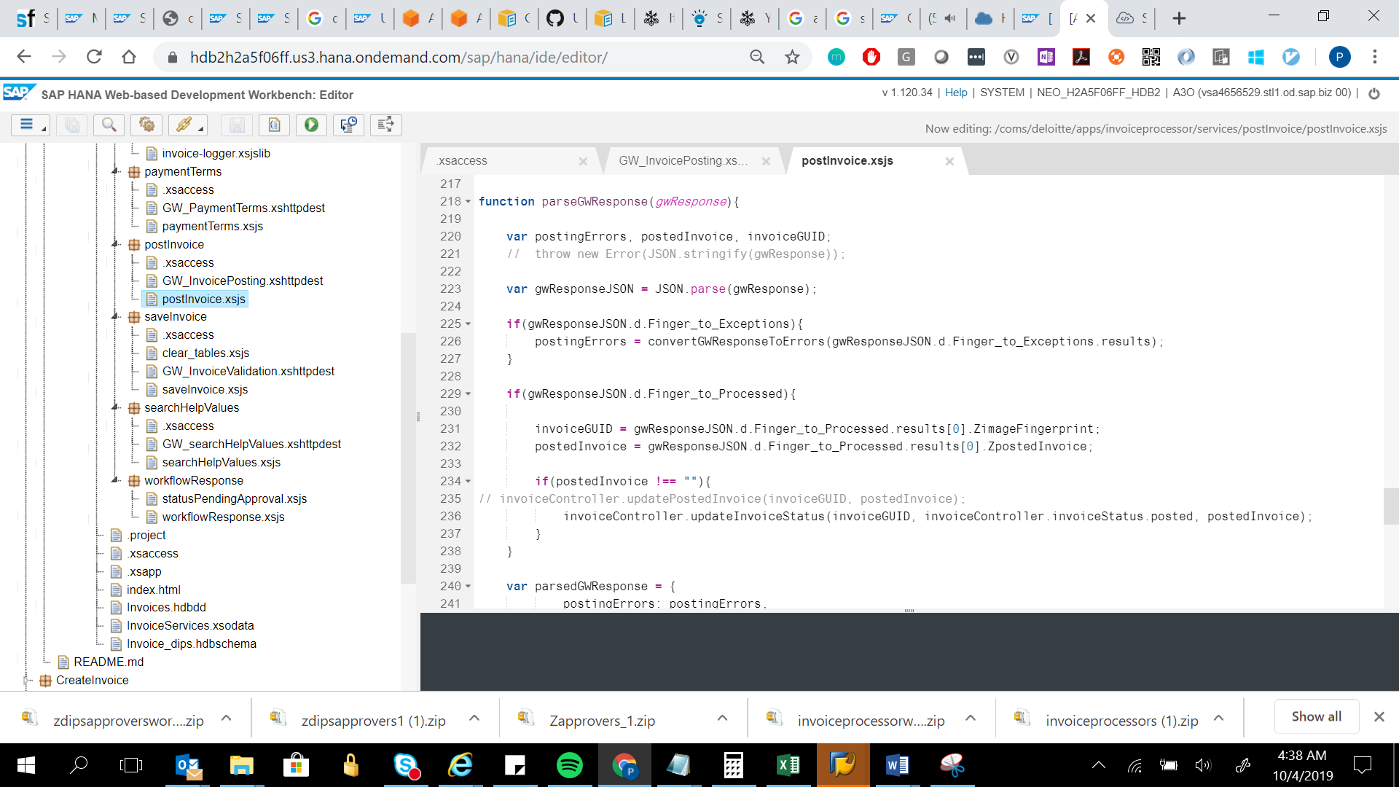

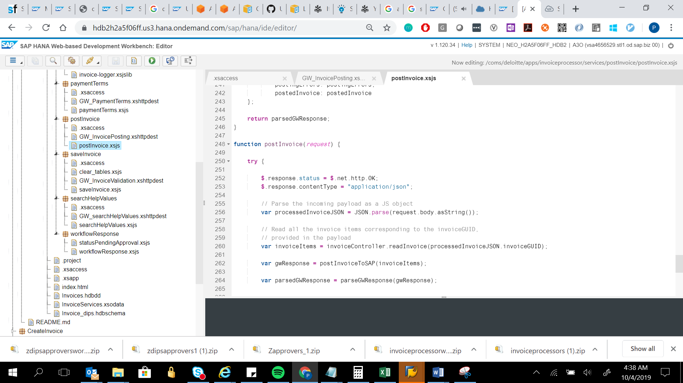

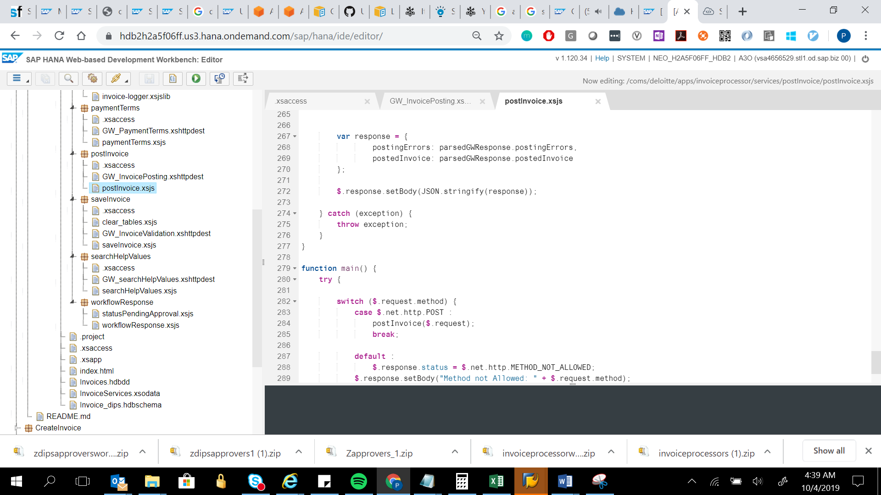

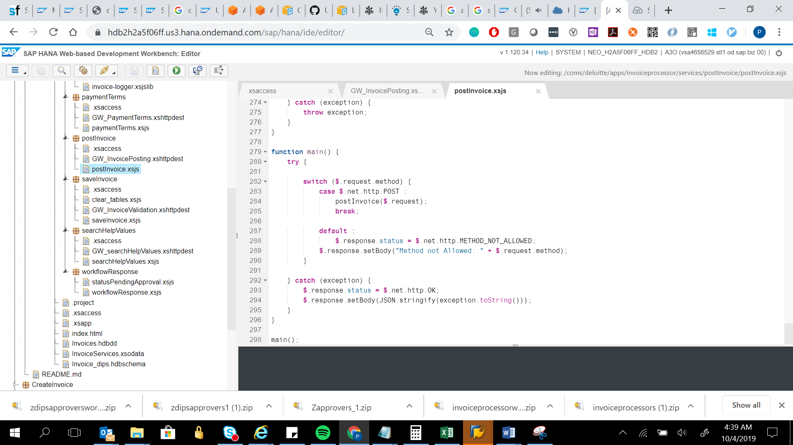

var invoiceController = $.import('../libs/invoice-controller.xsjslib');

function convertItemsToGWServicePayload(invoiceItems) {

var i, invoiceItem, gwInvoiceItems = [], gwInvoiceItem;

for (i = 0; i < invoiceItems.length; i++) {

invoiceItem = invoiceItems[i];

gwInvoiceItem = {

ZimageFingerprint: invoiceItem.invoiceGUID,

Zinvno: invoiceItem.invoiceID,

Zitemindex: invoiceItem.invoiceItemIndex,

ZdocType : invoiceItem.documentType,

ZdocDate : invoiceItem.documentDate,

Zinvdate : invoiceItem.invoiceDate,

ZpostingDate: invoiceItem.postingDate,

ZinvoicingParty : invoiceItem.invoicingParty,

ZcompanyCode : invoiceItem.companyCode,

Zcurrency : invoiceItem.paymentCurrency,

ZinvType: invoiceItem.invoiceType,

ZheaderText: invoiceItem.headerText,

ZvendorNo : invoiceItem.supplierNumber,

ZpaymentMethod: invoiceItem.paymentMethod,

ZpaymentBlock: invoiceItem.paymentBlock,

ZpartnerBank: invoiceItem.partnerBank,

ZhouseBank: invoiceItem.houseBank,

ZhouseBankAccid: invoiceItem.houseBankAccountID,

ZpaymentMethodSupp: invoiceItem.paymentMethodSupp,

ZautocalTax: invoiceItem.autoCalculateTaxIndicator,

ZtotalTaxAmt: invoiceItem.totalTaxAmount,

ZtaxJursidiction: invoiceItem.taxJurisdiction,

ZbaselineDate: invoiceItem.baselineDate,

ZdueOn: invoiceItem.dueDate,

ZvatAmount: invoiceItem.vatAmount,

ZvatAmount1: invoiceItem.vatAmount1,

ZvatAmount2: invoiceItem.vatAmount2,

ZvatAmount3: invoiceItem.vatAmount3,

ZvatAmount4: invoiceItem.vatAmount4,

ZvatRate: invoiceItem.vatRate,

ZvatRate1: invoiceItem.vatRate1,

ZvatRate2: invoiceItem.vatRate2,

ZvatRate3: invoiceItem.vatRate3,

ZvatRate4: invoiceItem.vatRate4,

ZpaymentTerm: invoiceItem.paymentTerm,

Zday1: invoiceItem.day1,

Zday2: invoiceItem.day2,

Zday3: invoiceItem.day3,

Zdisc1: invoiceItem.discount1,

Zdisc2: invoiceItem.discount2,

ZexchangeRate: invoiceItem.exchangeRate,

Zwht: invoiceItem.withholdingTax,

ZunplannedDeliveryCost: invoiceItem.unplannedDeliveryCost,

ZinstKey: invoiceItem.instanceKey,

ZbankAcc: invoiceItem.bankAccount,

ZbankName: invoiceItem.bankName,

ZbankNo: invoiceItem.bankNumber,

ZbankPartnerType: invoiceItem.bankPartnerType,

ZvatId: invoiceItem.vatID,

ZvatId1: invoiceItem.vatID1,

ZvatId2: invoiceItem.vatID2,

ZvatId3: invoiceItem.vatID3,

ZvatId4: invoiceItem.vatID4,

ZreqEmil: invoiceItem.requestorEmail,

ZinvFreightAmt: invoiceItem.invoiceFreightAmount,

ZinvHandlingCharges: invoiceItem.invoiceFreightAmount,

ZalternatePayee: invoiceItem.alternatePayee,

ZdocItmInInvDoc : invoiceItem.documentItemInInvoice,

ZpoNo : invoiceItem.purchaseOrder,

ZitemnoPurchingDoc : invoiceItem.itemPurchaseOrder,

ZpoUnitOfMeasure : invoiceItem.uomPurchaseOrder,

ZamtDocCurr : invoiceItem.amountDocumentCurrency,

ZitemDesc : invoiceItem.itemDescription,

ZunitPrice : invoiceItem.unitPrice,

ZdeliveryNote : invoiceItem.deliveryNoteNumber,

ZitemTaxAmt: invoiceItem.itemTaxAmount,

ZitemTaxRate: invoiceItem.itemTaxRate,

ZmaterialNo : invoiceItem.materialNumber,

ZtaxCode: invoiceItem.taxCode,

ZaccAssignBasedInv: invoiceItem.accountAssigned,

ZdirectPostGl : invoiceItem.directPostingGL,

ZdirectPostMaterial : invoiceItem.directPostingMaterial,

Zstatus: invoiceItem.invoiceStatus,

ZtimeStamp: invoiceItem.lastUpdatedTS,

ZlastUser: invoiceItem.lastUser,

ZcurrentUser: invoiceItem.currentUser,

ZlastUpdatedTimeStamp: invoiceItem.lastUpdatedTS,

ZlastRole: invoiceItem.lastRole,

ZinvoiceCategory: invoiceItem.invoiceCategory,

Zshiptoaddress1: invoiceItem.shipToAddress1,

Zshiptoaddress2: invoiceItem.shipToAddress2,

Zbilltocompany: invoiceItem.billToCompany,

Zbilltoname: invoiceItem.billToName,

Zbilltophone: invoiceItem.billToPhone,

Zbilltoaddr1: invoiceItem.billToAddress1,

Zbilltoaddr2: invoiceItem.billToAddress2,

Zbilltocountry: invoiceItem.billToCountry,

Zbilltovat: invoiceItem.billToVAT,

Zbilltoemail: invoiceItem.billToEmail,

Zreminame: invoiceItem.remitName,

Zremittoaddr1: invoiceItem.remitToAddress1,

Zremittoaddr2: invoiceItem.remitToAddress2,

Zremittopin: invoiceItem.remitToPin,

Zremittostreet: invoiceItem.remitToStreet,

Zremittovat: invoiceItem.remitToVAT,

ZremitToEmail: invoiceItem.remitToEmail,

ZremitToPhone: invoiceItem.remitToPhone,

ZsupplierNumber: invoiceItem.supplierNumber,

ZsupplierName: invoiceItem.supplierName,

ZsupplierName2: invoiceItem.supplierName2,

ZsupplierPoBox: invoiceItem.supplierPOBox,

ZsupplierPoBoxZip: invoiceItem.supplierPOBoxZip,

ZsupplierStreet: invoiceItem.supplierStreet,

ZsupplierState: invoiceItem.supplierState,

ZsupplierZip: invoiceItem.supplierZip,

ZnetAmount: invoiceItem.netAmount,

Zterms: invoiceItem.paymentTerms,

// "Zrate": "",

Ziban: invoiceItem.ibanNumber,

Zswift: invoiceItem.swiftCode,

ZgrossAmount : invoiceItem.grossAmount,

ZtotalTax : invoiceItem.totalTaxAmount,

Zitemno : invoiceItem.itemNumber,

Zitemprice : invoiceItem.itemPrice,

Zitemqty : invoiceItem.itemQuantity,

Zitemtax : invoiceItem.itemTax,

Zitemunit : invoiceItem.itemUnit,

Zitemqtyship : invoiceItem.itemQuantityShipped,

Ztotalamount : invoiceItem.totalAmount,

Zpgidate : invoiceItem.pgiDate,

ZitemCode : invoiceItem.itemCode,

ZdeliveryNoteNumber : invoiceItem.deliveryNoteNumber,

// "ZcurrentRole": "",

ZcompanyCodeLineItm: invoiceItem.itemCompanyCode,

ZglAccount: invoiceItem.glAccount,

ZglDescription: invoiceItem.glDescription,

ZcostCenter: invoiceItem.costCenter,

ZcostCenterDescription: invoiceItem.costCenterDescription,

Zwbs: invoiceItem.wbsElement,

ZwbsDescription: invoiceItem.wbsElementDescription,

ZinternalOrder: invoiceItem.internalOrder,

ZinternalOrderDescription: invoiceItem.internalOrderDescription,

Zasset: invoiceItem.assetID,

ZassetDescription: invoiceItem.assetDescription,

Zfilename: invoiceItem.invoiceFileName,

ZpostedInvoice: invoiceItem.postedInvoice

};

gwInvoiceItems.push(gwInvoiceItem);

}

return gwInvoiceItems;

}

function generateGWInvoicePostingPayload(invoiceItems) {

var gwInvoiceItems = convertItemsToGWServicePayload(invoiceItems);

var requestPayload = {

d : {

ZimageFingerprint : "",

Finger_to_Processed : gwInvoiceItems,

Finger_to_Exceptions : []

}

};

return requestPayload;

}

function postInvoiceToSAP(invoiceItems){

try {

var httpClient = new $.net.http.Client();

var gwInvoicePosting = $.net.http.readDestination(

"coms.deloitte.apps.invoiceprocessor.services.postInvoice",

"GW_InvoicePosting");

var request = new $.net.http.Request($.net.http.POST, "");

request.headers.set("X-Requested-With", "X");

request.headers.set("Content-Type", "application/json");

request.headers.set("Accept", "application/json");

request.headers.set("SAP-Connectivity-SCC-Location_ID", "SCPINVST");

request.headers.set("X-CSRF-Token", "CSRF");

var requestPayload = generateGWInvoicePostingPayload(invoiceItems);

request.setBody(JSON.stringify(requestPayload));

httpClient.request(request, gwInvoicePosting);

return httpClient.getResponse().body.asString();

} catch (exception) {

throw exception;

}

}

function convertGWResponseToErrors(gwPostingErrors){

var i, gwPostingError, postingErrors = [];

for(i = 0; i < gwPostingErrors.length; i++){

gwPostingError = gwPostingErrors[i];

postingErrors.push({

invoiceGUID: gwPostingError.ZimageFingerprint,

errorIndex: String(i),

errorMessage: gwPostingError.ZexceptionNo

});

}

return postingErrors;

}

function parseGWResponse(gwResponse){

var postingErrors, postedInvoice, invoiceGUID;

// throw new Error(JSON.stringify(gwResponse));

var gwResponseJSON = JSON.parse(gwResponse);

if(gwResponseJSON.d.Finger_to_Exceptions){

postingErrors = convertGWResponseToErrors(gwResponseJSON.d.Finger_to_Exceptions.results);

}

if(gwResponseJSON.d.Finger_to_Processed){

invoiceGUID = gwResponseJSON.d.Finger_to_Processed.results[0].ZimageFingerprint;

postedInvoice = gwResponseJSON.d.Finger_to_Processed.results[0].ZpostedInvoice;

if(postedInvoice !== ""){

// invoiceController.updatePostedInvoice(invoiceGUID, postedInvoice);

invoiceController.updateInvoiceStatus(invoiceGUID, invoiceController.invoiceStatus.posted, postedInvoice);

}

}

var parsedGWResponse = {

postingErrors: postingErrors,

postedInvoice: postedInvoice

};

return parsedGWResponse;

}

function postInvoice(request) {

try {

$.response.status = $.net.http.OK;

$.response.contentType = "application/json";

// Parse the incoming payload as a JS object

var processedInvoiceJSON = JSON.parse(request.body.asString());

// Read all the invoice items corresponding to the invoiceGUID,

// provided in the payload

var invoiceItems = invoiceController.readInvoice(processedInvoiceJSON.invoiceGUID);

var gwResponse = postInvoiceToSAP(invoiceItems);

var parsedGWResponse = parseGWResponse(gwResponse);

var response = {

postingErrors: parsedGWResponse.postingErrors,

postedInvoice: parsedGWResponse.postedInvoice

};

$.response.setBody(JSON.stringify(response));

} catch (exception) {

throw exception;

}

}

function main() {

try {

switch ($.request.method) {

case $.net.http.POST :

postInvoice($.request);

break;

default :

$.response.status = $.net.http.METHOD_NOT_ALLOWED;

$.response.setBody("Method not Allowed: " + $.request.method);

}

} catch (exception) {

$.response.status = $.net.http.OK;

$.response.setBody(JSON.stringify(exception.toString()));

}

}

main();

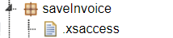

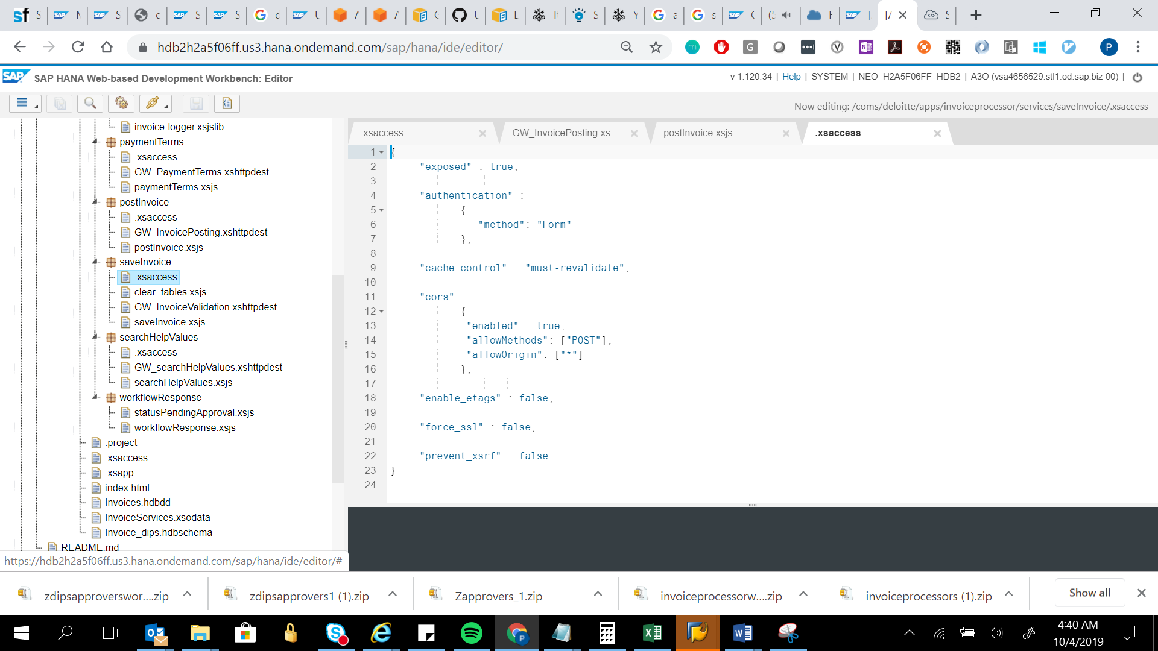

{

"exposed" : true,

"authentication" :

{

"method": "Form"

},

"cache_control" : "must-revalidate",

"cors" :

{

"enabled" : true,

"allowMethods": ["POST"],

"allowOrigin": ["*"]

},

"enable_etags" : false,

"force_ssl" : false,

"prevent_xsrf" : false

}

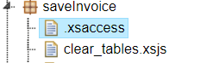

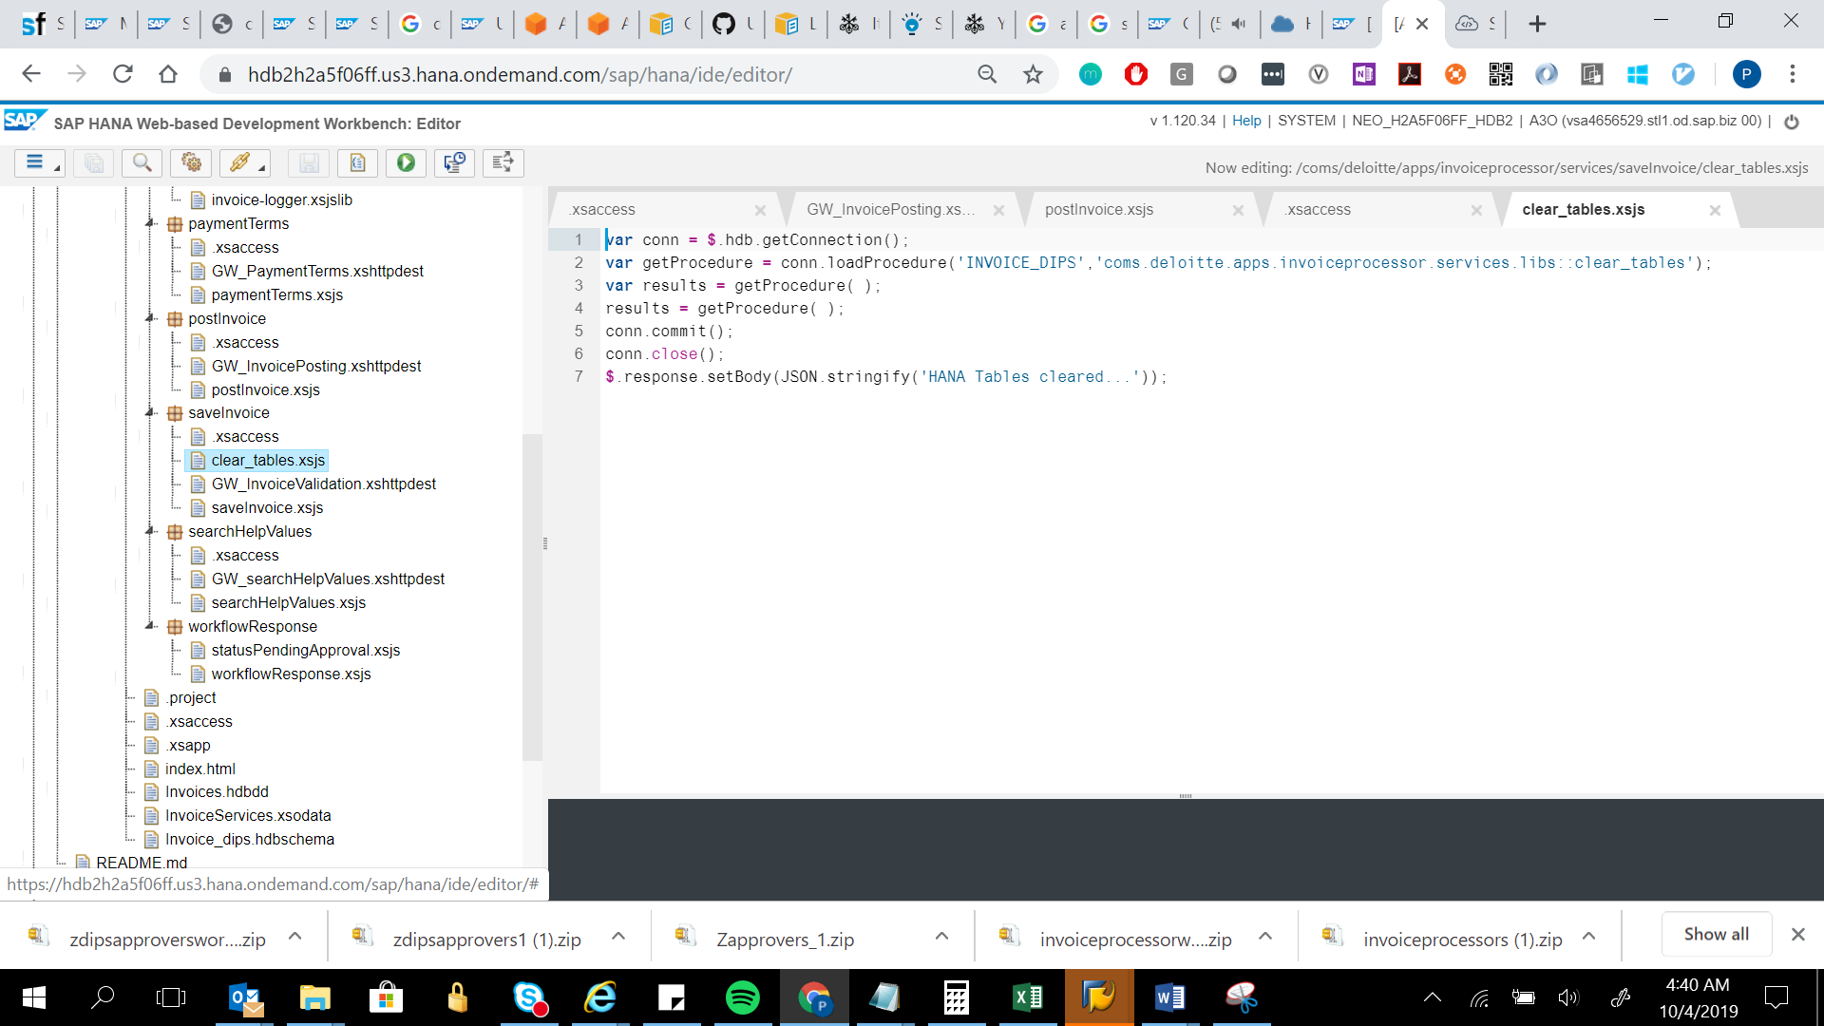

var conn = $.hdb.getConnection();

var getProcedure = conn.loadProcedure('INVOICE_DIPS','coms.deloitte.apps.invoiceprocessor.services.libs::clear_tables');

var results = getProcedure( );

results = getProcedure( );

conn.commit();

conn.close();

$.response.setBody(JSON.stringify('HANA Tables cleared...'));

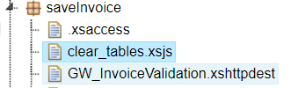

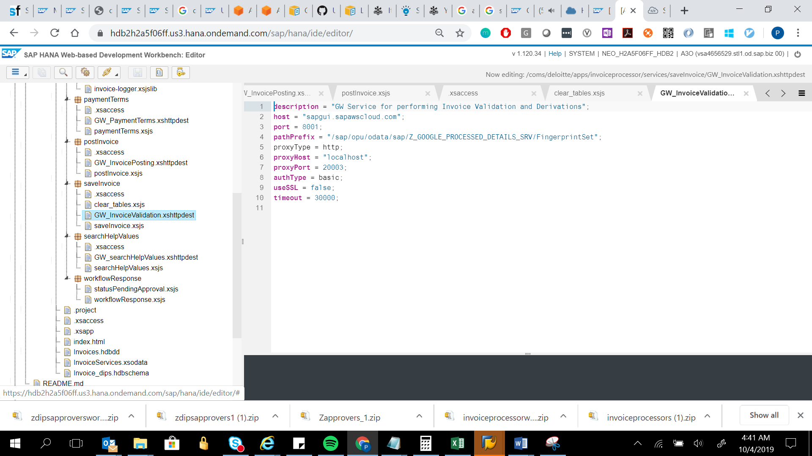

description = "GW Service for performing Invoice Validation and Derivations";

host = "sapgui.sapawscloud.com";

port = 8001;

pathPrefix = "/sap/opu/odata/sap/Z_GOOGLE_PROCESSED_DETAILS_SRV/FingerprintSet";

proxyType = http;

proxyHost = "localhost";

proxyPort = 20003;

authType = basic;

useSSL = false;

timeout = 30000;

